**TABLE OF CONTENTS**

* **Letter from the Secretary-General**
* **Letter from the USG and the Academic Assistant**
* **The Legalization Controversy on the Status of Drugs**
  + **Definition of Key Terms**
    - **Drug**
    - **Narcotic**
    - **Illicit Drugs**
    - **Convention**
    - **War on Drugs**
    - **STD / HIV / AIDS**
  + **Legalization vs. Decriminalization**
  + **Background Information**
  + **Major Countries**
    - **Portugal**
    - **Phillippines**
    - **Uruguay**
    - **USA**
    - **UK**
    - **Netherlands**
    - **Canada**
    - **Russian Federation**
    - **Mexico**
  + **Relevant UN Treatıes, Resolutıons and Important Acts of The Countrıes**
    - ***Single Convention on Narcotic Drugs(1961)***
    - ***Misuses of Drugs Act(UK)(1971)***
    - ***Controlled Substances Act(USA)(1971)***
    - ***Convention on Psychotropic Substances(1971)***
    - ***United Nations Convention Against Illicit Traffic in Narcotic Drugs and Psychotropic Substances(1988)***
    - ***Convention on the Rights of Child(1989)***
    - ***United Nations Convention Against Transnational Organized Crime(2000)***
  + **Questions that Resolution Must Cover**
* **Ethical Barriers on Genetic Modification Studies**
  + **Introduction**
  + **Definition of the Key Words**
    - **Ethics**
    - **Bioethics**
    - **Genetic Modification**
    - **Autonomy**
  + **Information and Discussion**
  + **Major Countries**
  + **Relatıve UN Treatıes, Resolutıons, and Important Acts From Some of The Major Countrıes**
  + **Questıons that Need to Be Dıscussed and Resolutıon Must Cover**
* **Bibliography**

**LETTER FROM the Secretary-General**

**LETTER FROM the USG and the Academic Assistant**

Dear delegates,

We welcome you all to the IUMUN 2023. It is a pleasure to serve you as the Under-Secretary-General and the Academic Assistant of General Assembly-6: LEGAL Committee.

We tried to choose agenda items that would be familiar and easy to discuss especially for first-timers. We couldn’t be impartial because of my department, but we’re sure you will enjoy them too. Even a short research on the internet and reading of this study guide will be enough for you to gain basic knowledge on the topic and your country’s policy. You can contact us if you cannot find any information.

To put it briefly, we do not want the committee and conference to scare you. We would like to remind you that you will discuss solutions to issues for which sufficient international solutions have not been found yet.

Even if I, as the USG, will not be able to participate in the conference, it is my honor to have you here on our precious committee. We hope you have the greatest time of your MUN career. If you have any questions, please do not hesitate to ask via email ([cansu.sahin10@ogr.iuc.edu.tr](mailto:cansu.sahin10@ogr.iuc.edu.tr)).

Best wishes,

Cansu Şahin and Umut Işık Usluyer

The Legalization Controversy on the Status of Drugs

**DEFINITION OF KEY TERMS**

***Drug***

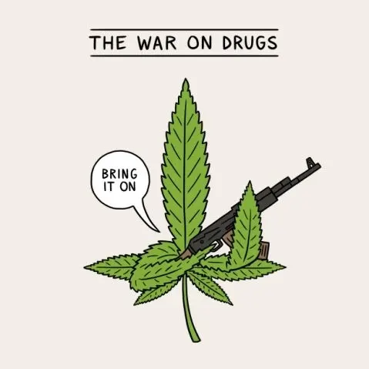A drug is a medicine or other substance which has a physiological effect when ingested or otherwise introduced into the body.

***Narcotic***

Narcotic when originally referred to as a medical substance means any psychoactive compound with paralyzing or numbing properties. But, in terms of legal vocabulary, the word might get associated with the usage of illicit drugs or controlled substances.

***Illicit Drugs***

It refers to drugs that are banned or regulated by the laws, rules, or customs of states or any other governing/regulating position.

***Convention***

It refers to an agreement between states covering particular matters.

***War on Drugs***

“The War on Drugs” is a phrase used to refer to a government-led program that aims to end illicit drug use, trade, and distribution by increasing punishments for drug users and dealers.

***STD / HIV / AIDS***

STDs (Sexually Transmitted Diseases) are infections that can pass from one person to another through vaginal, oral, and anal sex.

HIV (Human Immunodeficiency Virus) is a virus that attacks the body’s immune system. If HIV is not treated, it can lead to AIDS (acquired immunodeficiency syndrome). In conclusion, HIV is a virus that weakens the immune system and AIDS is a condition resulting from an HIV infection.

**LEGALIZATION vs. DECRIMINALIZATION**

Decriminalization and legalization are two different concepts. Decriminalization removes criminal penalties for possessing and using any drug for personal use. Nevertheless, there are still criminal penalties for manufacturing and selling drugs. Decriminalization does not establish legal regulations for the cultivation, production, or sale of any drugs.

Legalization removes criminal penalties for possessing and using any drug too. In addition, regulations are established to control where and how the legal drug can be maintained, sold, and consumed. Legal sanctions may be applied if production or consumption takes place outside the regulations.

**BACKGROUND INFORMATION**

The War on Drugs began in June 1971 when U.S. Pres. Richard Nixon declared drug abuse to be "public enemy number one" and increased federal funding for drug-control agencies and drug-treatment efforts. John Ehrlichman, Nixon's aide, later stated: "You want to know what this was all about. The Nixon campaign in 1968, and the Nixon White House after that, had two enemies: the antiwar left and black people. You understand what I'm saying. We knew we couldn't make it illegal to be either against the war or black, but by getting the public to associate the hippies with marijuana and blacks with heroin, and then criminalizing both heavily, we could disrupt those communities. We could arrest their leaders, raid their homes, break up their meetings, and vilify them night after night on the evening news. Did we know we were lying about the drugs? Of course, we did.”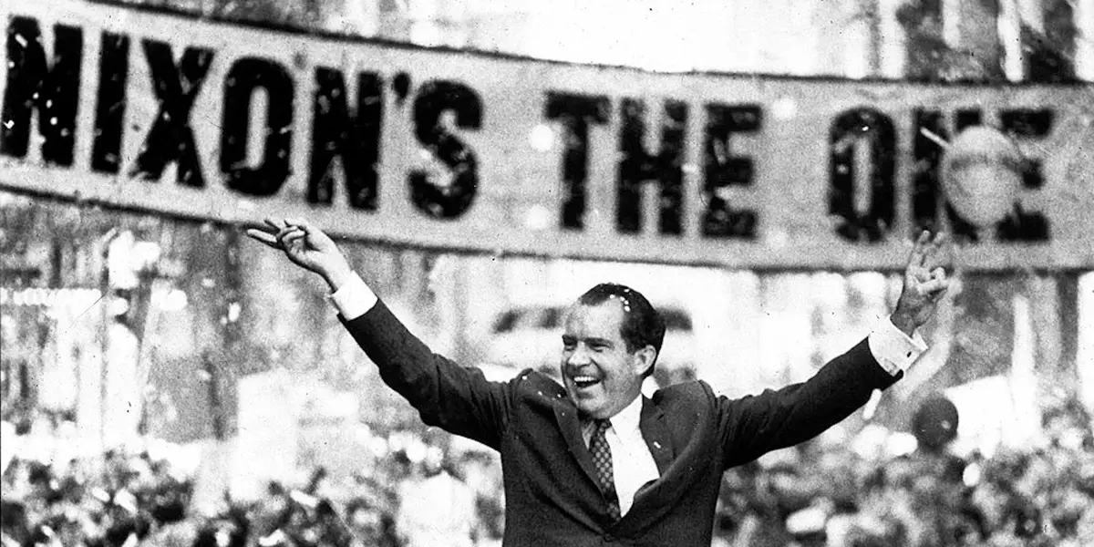

The commission recommended decriminalization of possessing marijuana for personal use in 1972. Despite this, Nixon disregarded the commission and reject their recommendation.

In 1973 the Drug Enforcement Administration was created out of the merger of the Office for Drug Abuse Law Enforcement, the Bureau of Narcotics and Dangerous Drugs, and the Office of Narcotics Intelligence to consolidate federal efforts to control drug abuse.

In January 1977, U.S. President Jimmy Carter began taking part in a campaign for the decriminalization of marijuana. In October, decriminalizing possession of an ounce of marijuana for personal use was approved by the Senate Judiciary Committee. Within a few years, the usage of drugs has increased especially among teens.

With the election of Ronald Reagan as the president of the United States in 1981, the effect of the "war on drugs" increased rapidly. The U.S. Congress voted in favor of the Anti-Drug Abuse Act of 1986, which allocated $1.7 billion to the War on Drugs and established “mandatory minimum” prison sentences for various drug offenses. All these and other implements that are not referred to, which were performed by taking strength from the public who were affected by the increase in the numbers of addicts, continued to enlarge until the end of the 1980s. With the strict drug procedures prison populations have rapidly increased. These procedures also blocked the syringe access programs and other harm reduction policies to reduce the spread of HIV/AIDS. 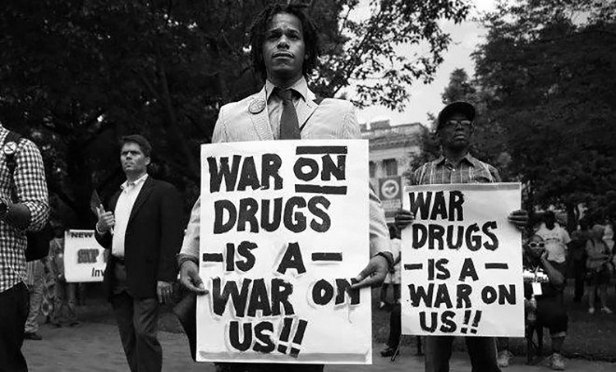

In the late 1980s and early 1990s, a large group of people was seeking a new approach to drug policy. In 1987, the Drug Policy Foundation was founded– described as the “loyal opposition to the war on drugs.”.

During the 1992 presidential campaign of Bill Clinton, he supported treatment instead of imprisonment. After a while in the White House, he maintained the same strategies which his predecessors apply. He also rejected the U.S. Sentencing Commission's recommendation to eliminate the disparity between crack and powder cocaine sentences, and Health Secretary Donna Shalala’s advice to end the federal ban on funding for syringe access programs. After all, in 2001 he admitted that "We need a re-examination of our entire policy on imprisonment" and stated marijuana should be decriminalized.

After the 21st century, state-level reforms finally began to slow the growth of the war on drugs. Even politicians started to admit that they used drugs before. People’s opinion has significantly changed in favor of reforms that expand health-based strategies while decreasing the role of criminalization in drug policy.

In December 2013, Uruguay became the first country to legally regulate marijuana.

In 2014 within the European Union, a European Citizens' Initiative called Weed Like to Talk was launched to start a debate in Europe about the legalization of the production, sale, and use of marijuana in the European Union and find a common policy for all EU member states.

Today, the focus of the world's drug policy reform organizations is on the promotion of harm reduction in the Western World, and attempting to prevent the catastrophic loss of human life in developing countries where much of the world's supply of heroin, cocaine, and marijuana are produced.

Drug policy reform advocates point to failed efforts such as the Mexican Drug War, which according to some observers has claimed as many as 80,000 lives, as signs that a new approach to drug policy is needed.

**MAJOR COUNTRIES**

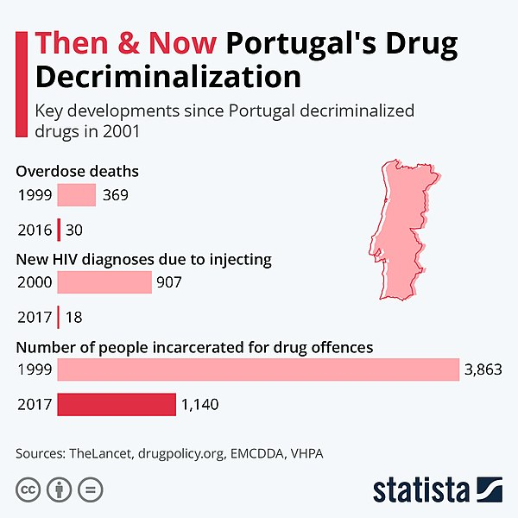 ***Portugal***

Back in the 1990s, Portugal faced a barely comprehensible crisis, one in every 100 citizens in the country was addicted to heroin. In 2001, Portugal decriminalized the personal use and possession of all illicit drugs. They treated drug users as healthcare patients. After having successful results, Norway signaled its intent to follow Portugal’s lead toward decriminalization in a landmark vote.

In 2015, Portugal had the lowest drug-induced death rate in Western Europe, then times lower than the United Kingdom, and fifty times lower than the United States.

***Philippines***

When Rodrigo Duterte was elected as president in 2016, he extremely increased the penalties. He promised to kill every drug dealer and user in the country. In 2020, the UN reported that between 8,000 and 25,000 people had lost their lives in the name of the war on drugs. Even under these circumstances, the dealers and gangs do not fear the police. In 2020, the head of drug enforcement gave an interview, he admitted the violent approach was failing.

***Uruguay***

Uruguay has taken a unique and progressive approach to drug policy, particularly regarding cannabis. In 2013, Uruguay became the first country in the world to legalize the production, sale, and consumption of marijuana for recreational purposes. This groundbreaking move aimed to regulate the cannabis market, minimize the influence of criminal organizations and prioritize public health and safety. The government established a state-controlled regulatory framework that includes licensed cultivation, distribution, and sales.

This approach has allowed for greater control over the market, quality assurance, and taxation. Uruguay's drug policy is founded on the principle of harm reduction, recognizing that drug use exists and aiming to mitigate associated risks rather than relying solely on criminalization. While the impact of this policy is still under study, it has sparked international debates on alternative drug regulation models and highlighted the potential benefits of a more holistic approach to drug control.

***United States of America***

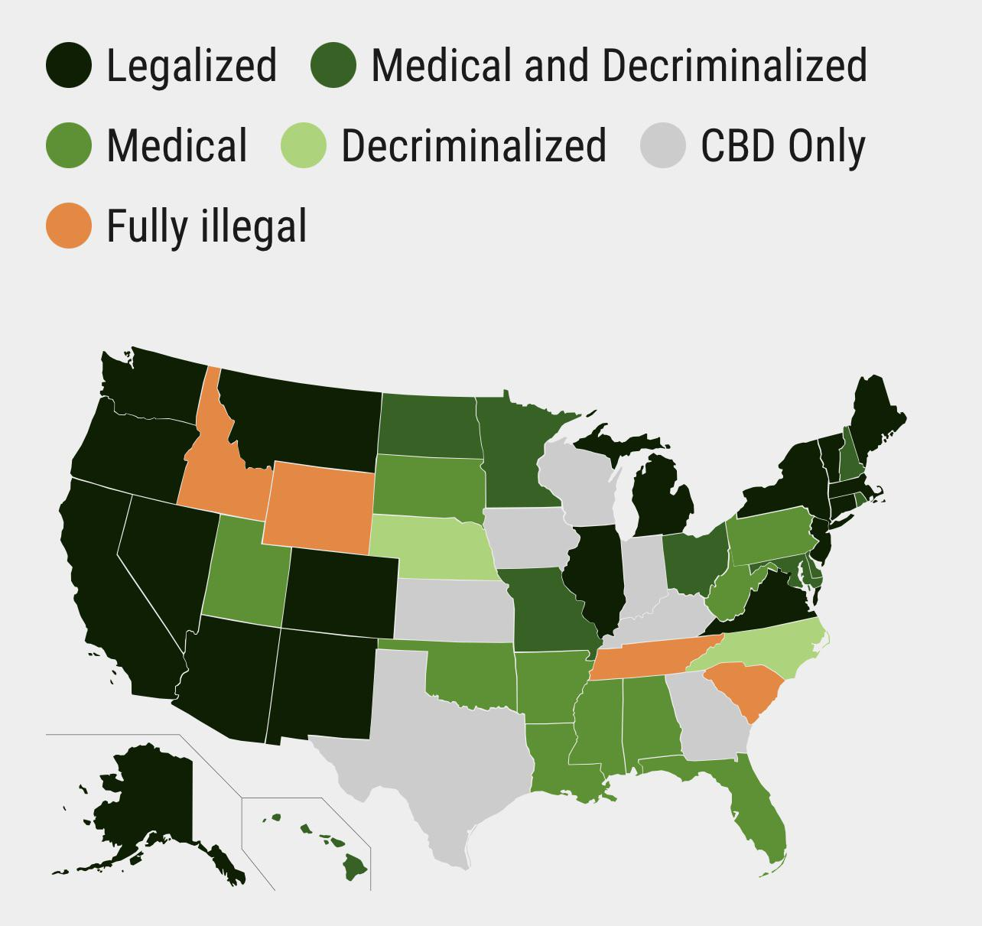 The major federal agency responsible for administering drugs, laws, and regulations is the Drug Enforcement Agency (DEA). Possession, use, or distribution of illicit drugs is prohibited by federal law. Strict penalties are provided for drug convictions, including mandatory prison terms for many offenses. Penalties increase significantly where use of the illicit drugs results in death or serious bodily injury. (A large number of states have legalized/decriminalized marijuana for medical and personal use.)

***United Kingdom***

The United Kingdom government mainly focused on harm reduction and minimizing the side effects. Possession, distribution, and use of drugs are illegal depending on the amount you own. From 1964 usage of drugs was progressively criminalized. And the framework is still mostly determined by the Misuse of Drugs Act 1971.

***Netherlands***

In the Netherlands, it is illegal to possess, distribute or use drugs. On the other hand, the government tolerates the sale of soft drugs in coffee shops. The government is trying to decrease the crime rates by regulating the rules on coffee shops, dismantling drug operations, and inhibiting the possession/distribution/usage of hard drugs. The government also provides a health care system for addicts.

***Canada***

In 2018, Canada became the second country in the world to legalize marijuana, following Uruguay. This decision aimed to regulate the market, lower crime levels and promote public health and safety. The legalization process created opportunities for research, taxation, and economic growth in the industry. The government has taken steps toward reducing the harms of drugs by providing therapy centers and implementing injection sites. etc.

Recently, the idea of “drug courts” has gained popularity in Canada. The aim of the “drug courts” is to direct drug offenders to treatment programs instead of prisons. In the drug courts in Toronto out of 284 criminals referred to the drug court, over two-thirds have been expelled from the program.

***Russian Federation***

The current drug policy in Russia is considered strict and cruel due to the government's approach. The Russian Federation maintains a zero-tolerance stance on drug offenses. The government believes in a strict criminalization policy may act as a deterrent factor to drug use. There is no intention of treatments or harm reduction procedures.

***Mexico***

In 2009, the Mexican government decriminalized the possession of drugs on a small scale. The maximum amount which could be accepted for “personal use” was established. This new law also gives state-level police the authority to apprehend small-scale dealers and accepts harsh penalties for drug dealers on the streets. It is now legal to possess marijuana in Mexico since 2021.

It should not be forgotten that drug trafficking is a significant problem in Mexico. There are a few main reasons why; Mexico has borders with the US which is the largest drug consumer market in the world, and Mexico’s socio-economical status creates a proper environment for drug dealers. The high demand for illicit drugs, coupled with the profitability of the drug trade, fuels the ongoing cycle of drug trafficking in Mexico, leading to violence, social instability, and significant challenges for law enforcement and security forces.

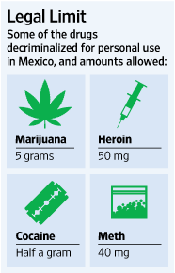

**RELEVANT UN TREATIES, RESOLUTIONS, AND IMPORTANT ACTS OF THE COUNTRIES**

***1. Single Convention on Narcotic Drugs(1961)***

This treaty serves as the cornerstone of international drug control efforts. The convention controls activities such as; the cultivation, production, supply, trade, and transport of some narcotic drugs and lays down a system of regulations for their medical and scientific use. Also, the convention saw the establishment of the ***International Narcotics Control Board.***  Although some amendments and ratifications were made throughout the years, the convention remained mostly unchanged.

<https://www.unodc.org/pdf/convention_1961_en.pdf>

***2. Misuses of Drugs Act(UK)(1971)***

This Act was passed by the British to prevent the misuse of controlled drugs and achieves this by imposing a complete ban on the possession, supply, manufacture, import, and export of controlled drugs except as allowed by regulations or by license from the Secretary of State of the United Kingdom.

<https://www.legislation.gov.uk/ukpga/1971/38/contents>

***3.Controlled Substances Act(USA)(1971)***

The Controlled Substances Act (CSA), a federal law regulating drug policy in the United States, regulates the production, importation, possession, use, and distribution of specific substances. The act also served as a national implementation of the Single Convention on Narcotic Drugs.

<http://www.naabt.org/documents/controlled-substances-act.pdf>

***4. Convention on Psychotropic Substances(1971)***

This treaty is designed and focused on the newly found psychoactive drugs such as but not limited to; amphetamine-type stimulants, barbiturates, benzodiazepines, etc. The treaty was ultimately signed to supplement the **Single Convention on Narcotic Drugs** which didn't see any kind of bans or regulations about psychoactive drugs.

<https://www.unodc.org/pdf/convention_1971_en.pdf>

**5. *United Nations Convention Against Illicit Traffic in Narcotic Drugs and Psychotropic Substances(1988)***

The convention is one of the three major treaties that are currently in force. It adds up some new regulations and legal mechanisms for enforcing what was implemented by the **Single Convention on Narcotic Drugs(1968)** and **Convention on Psychotropic Substances(1971)**.

<https://www.unodc.org/pdf/convention_1988_en.pdf>

***6. Convention on the Rights of Child(1989)***

Although the convention itself wasn't about drugs or any other drug-related crimes, the convention still provided some legal basis for the ban on drug usage among children. (ARTICLE 33)

[https://www.unicef.org/child-rights-convention/convention-text#](https://www.unicef.org/child-rights-convention/convention-text)

***7. United Nations Convention Against Transnational Organized Crime(2000)***

This convention addresses various forms of organized crimes, including drug trafficking, and seeks international cooperation in investigating and prosecuting drug-related crimes.

<https://www.unodc.org/documents/middleeastandnorthafrica/organised-crime/UNITED_NATIONS_CONVENTION_AGAINST_TRANSNATIONAL_ORGANIZED_CRIME_AND_THE_PROTOCOLS_THERETO.pdf>

**QUESTIONS THAT RESOLUTION MUST COVER**

-How can member countries cooperate internationally to address the global drug problem and prohibit the trafficking of illegal substances? What processes may be established to facilitate information sharing, intelligence sharing, and joint law enforcement efforts?

-How can member states ensure that drug legalization efforts align with international legal frameworks, including the United Nations drug control treaties? Can there be modifications or amendments to these treaties to accommodate evolving perspectives on drug policy?

-What are the potential economic impacts of drug legalization? How can member states assess and manage these impacts, including taxation, licensing, and revenue allocation for drug-related industries?

-What steps may be made to protect the rights of people who are impacted by drug policies, particularly at-risk groups such as drug users, addicts, and marginalized groups?

-How can member countries promote scholarly research into the benefits, risks, and potential medicinal applications of illegal substances? How may the findings of the study affect laws and regulations that are backed by facts?

**---------------------------------------------------------------------------------------------------------------------------**

Ethical Barriers on Genetic Modification Studies

**INTRODUCTION**

For over 40 years, scientists have been able to modify the genome of mammalian cells genetically. The first transgenic mouse was created in 1974 by Rudolf Jaenisch. Since this time various techniques have been used to insert, delete or modify DNA, to create animals with altered physical, cognitive, and social characteristics. While invaluable to advance basic research, the potential clinical applications have been hampered by the challenge of reliably modifying the desired genome sequence without any off-target effects. However, advances over the past six years have led to more precise and efficient methods for genetic engineering, raising the specter of 'editing' the genomes of our cells or even those of our descendants at will.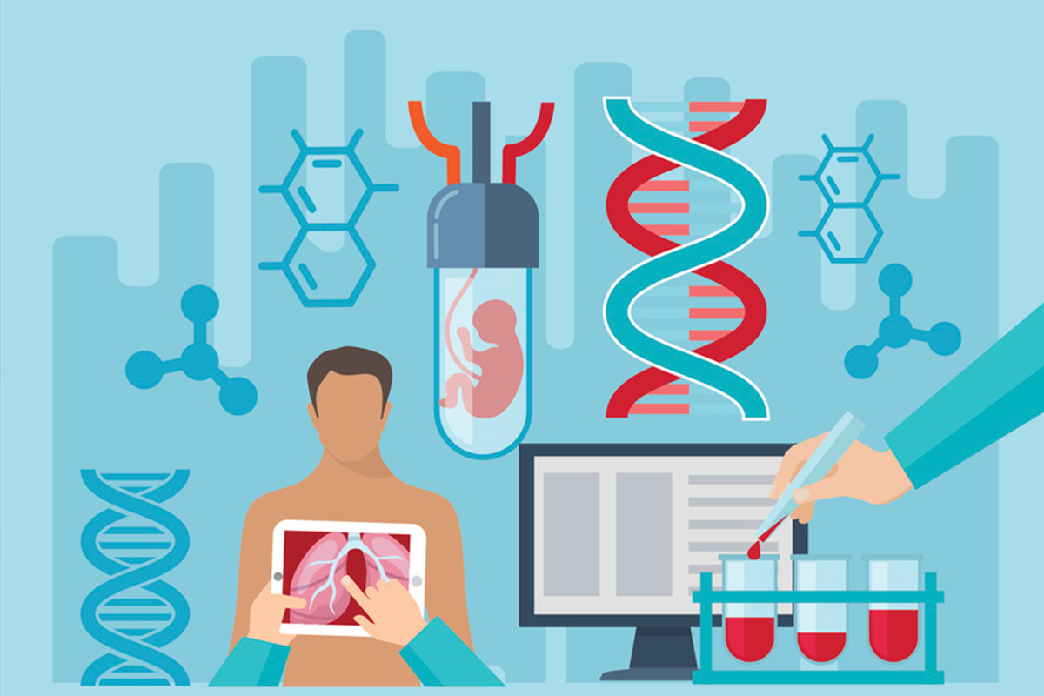

The most notable of these advanced ‘genome editing’ techniques is the CRISPR-Cas9 system. This approach showed that CRISPR-Cas9 could be modified so that it could target virtually any DNA sequence, giving researchers the ability to delete, add, or modify DNA sequences. The CRISPR-Cas9 approach has since been used to modify the genome of mice, dogs, pigs, and primates.

Genome editing has come a long way. It is still a matter of debate around the scientific society, whether it is ethical or a possible disaster. A significant amount of people think that playing with genes will go beyond treatment and that people will take advantage of genome editing by “designing” the “superior race”. On the other hand, it should not be forgotten that genome editing technology can potentially change current medical treatments and it also has the potential to decrease human diversity and increase social inequality.

**DEFINITION OF KEYWORDS**

***Ethics***

Ethics is a branch of philosophy that "involves systematizing, defending, and recommending concepts of right and wrong behavior".

***Bioethics***

Bioethics is the study of ethical, social, and legal issues that arise in biomedicine and biomedical research.

***Genetic Modification***

Genetic modification is a technique to change the characteristics of a plant, animal, or microorganism by transferring a piece of DNA from one organism to a different organism.

***Autonomy***

Autonomy is the ability to make your own decisions about what to do rather than being influenced by someone else or told what to do. It is about a person's ability to act on his or her values and interests.

**INFORMATION & DISCUSSION**

In today’s medical/scientific ethics, four principles are accepted: 1)utility, 2) not harm, 3)respect for autonomy, and 4)justice.

The vast majority of scientific information so far has been obtained through inhumane and unethical actions. There are countless examples of this from ancient times to the 20th century. For example: in the 19th century, a gynecologist named James Marion Sims performed cruel experiments on black women who underwent experimental surgeries without anesthesia. Sims is considered the “Father of Modern Gynecology” despite his horrific experiments that caused numerous deaths since he contributed so much valuable information to medicine.

While referring to the contribution of unethical actions to medicine, it would be wrong not to mention the holocaust. The human experiments during World War 2 illustrate the brutal consequences of not controlled science. Though these experiments were unquestioningly inhumane, they did contribute to several medical and scientific breakthroughs. The key takeaway from these past experiences is that, while unregulated scientific progress can yield significant advancements, it comes at an intolerable ethical cost. Applying this lesson to genetic modifications, it is possible to see the potential dangers of allowing uncontrolled manipulation of the human genome. This could potentially lead to exploitation and discrimination, echoing past atrocities.

After WW2, Nuremberg Code has been published. This code consists of 10 basic ethical research principles for human experimentation. (for further information: <https://en.wikipedia.org/wiki/Nuremberg_Code#The_ten_points_of_the_Nuremberg_Code>)

Dolly the Sheep became the world’s first successfully cloned animal in 1996. This huge progress raised profound ethical questions and ignited discussions in the field of bioethics. The cloning technology raises concerns about the potential for manipulating the genetic makeup of offspring, challenging the natural process of procreation and raising moral concerns. Bioethical considerations call for careful evaluation of the potential risks, ethical implications, and long-term consequences associated with human reproductive cloning. 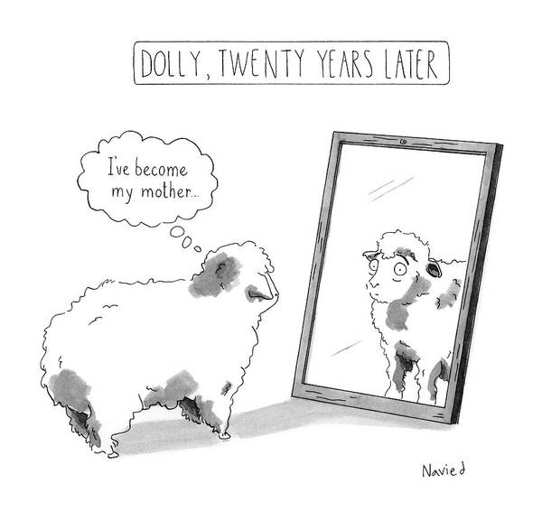

On December 10, 2020, a ferret named Elizabeth Ann was born, it is the first endangered species to be cloned. The animal was cloned using the frozen cells from a ferret who died in the 1980s. Elizabeth Ann will be studied for scientific purposes. In a museum’s panel discussion, it is informed that other clones were on their way.

It is safe to say that cloning animals has been achieved in various species such as sheep, pigs, dogs, etc. Even though cloning of animals is technically feasible, it remains a complex and expensive process with high failure rates. Animal cloning is done primarily for research purposes, agricultural advances, and the conservation of endangered species.

On the other hand, cloning of humans is considered unethical and is banned in plenty of countries. International agreements and legal structures that forbid the practice of human cloning have been established in response to scientific and ethical concerns. The UN Declaration on Human Cloning called for a global ban on all forms of human cloning in 2005.

There are two commonly discussed human cloning types which are therapeutic cloning and reproductive cloning. Therapeutic cloning stands for creating cloned embryos for extraction cells for medical research/treatment. It is not in medical practice anywhere in the world as of 2023. Reproductive cloning would involve making an entire cloned human, instead of specific cells or tissues. Dolly the SHeep was produced with this technology. The knowledge that can be obtained using these technologies can lead to excellent developments in the literature.

**MAJOR COUNTRIES**

***United States***

No regulation in the USA prohibits therapeutic or reproductive cloning. The regulations adopted in the House of Representatives in 998, 2001, 2004, and 2007 to ban both types of cloning could not enter into force because they did not pass the Senate. However, in 2010, a regulation prohibiting the allocation of public funds to human cloning and research was adopted and entered into force. At the state level, 13 states have passed laws banning both types of cloning. Apart from these, at least 12 states are in preparation for similar bans. Some states do not prohibit cloning but only prevent the allocation of public funds.

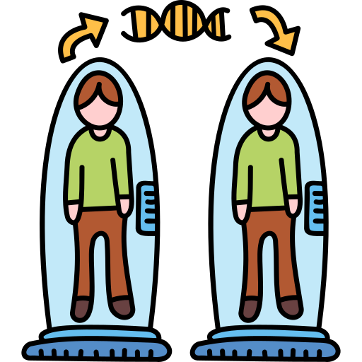

***United Kingdom***

The UK has been regulating this issue since 1990. With the change made in 2008, the Human Fertilization and Embryo Institution was established. This institution grants licenses for the research and treatment of embryos. According to these regulations, 14 days after fertilization, the use of embryo, human-animal insemination is prohibited and penalized. Placing a human embryo prepared outside of fertilization into a woman was also considered a crime and sentenced to up to ten years in prison.

***Japan***

The Cloning Law came into force in 2001 and regulates and outlaws techniques for human or hybrid cloning. According to this law, transplanting clone embryos, human-animal hybrid embryos, human nuclear transfer embryos, and human-creature embryos into a human or animal womb are counted as prohibited acts. In the future, the act will go unpunished in the event of the invention of another tool, other than the mother's womb, with which the embryo can continue its development.

***Denmark***

With the regulation made in the Medically Assisted Reproduction Law in 2003, if the purpose of the research is to obtain information about the treatments to be applied to human diseases, it allows. However, these studies are prohibited from aiming at reproductive cloning, mixing genes, combining different species to create hybrids, and developing human beings outside the womb. This regulation of the Danish law also foresees possible developments in the future.

***Greece***

According to the law passed by the Greek government, the remnants of embryos obtained as a result of in vitro fertilization are allowed to be used for research and therapeutic purposes. Only reproductive cloning is prohibited. It is stated in the texts explaining the relevant law that only reproductive cloning is prohibited and should be interpreted as allowing therapeutic cloning.

***Russian Federation***

The Federal Assembly of Russia introduced Federal Law N 54-FZ "On the temporary ban on human cloning" on 19 April 2002. On 20 May 2002, President Vladimir Putin signed this moratorium on the implementation of human cloning. On 29 March 2010, The Federal Assembly introduced a second revision of this law without a time limit.

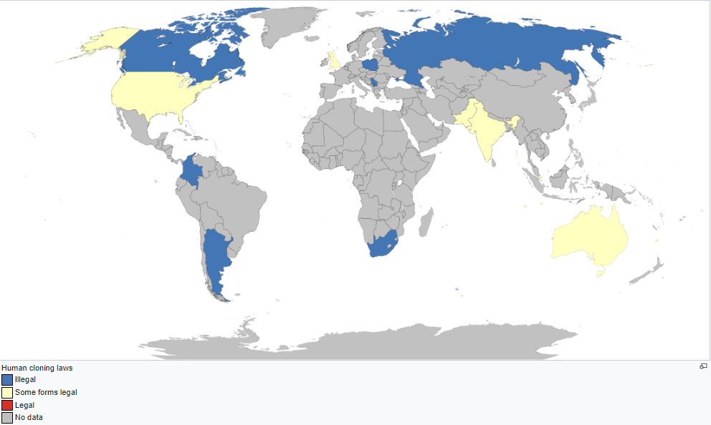

**RELATIVE UN TREATIES, RESOLUTIONS, AND IMPORTANT ACTS FROM SOME OF THE MAJOR COUNTRIES**

***1. Universal Declaration on the Human Genome and Human Rights(1997)***

This declaration emphasizes the ethical principles and human rights considerations with genetic research and applications. It addresses issues such as privacy, non-discrimination, informed consent, and the potential impacts of genetic intervention on future generations.

<https://www.ohchr.org/en/instruments-mechanisms/instruments/universal-declaration-human-genome-and-human-rights>

***2.Oviedo Convention(1997)(European Union)***

This convention covers a wide range of biomedical ethics concerns, including some for genetic testing and treatments. It lays out concepts about human dignity, consent, genetic testing, and defense of the weak. Although the convention itself was signed by the Council of Europe, it still affected other countries around the globe as it answered some of the ethical questions regarding genetic modification.

<https://rm.coe.int/168007cf98>

***3. International Declaration on Human Genetic Data(2003)***

This declaration highlights the importance of protecting human genetic data, ensuring privacy, and promoting responsible usage of genetic information. It recognizes the need for international cooperation in safeguarding the ethical use and sharing of human genetic data

<https://www.unesco.org/en/legal-affairs/international-declaration-human-genetic-data?hub=66535>

***4. UNESCO Universal Declaration on Bioethics and Human Rights(2005)***

The ethical guidelines for research and applications in the field of life sciences, including genetic alteration, are outlined in this proclamation. In the context of bioethical challenges, it emphasizes human dignity, informed consent, equity, and solidarity.

<https://www.unesco.org/en/legal-affairs/universal-declaration-bioethics-and-human-rights?hub=66535>

***5.Human Fertilisation and Embryology Act(2008)(UK)***

This act regulates assisted reproductive technologies, including the creation and use of embryos for research purposes, and sets out ethical standards for genetic modification. Also, this act repealed and replaced the **Human Reproductive Cloning Act of 2001.**

<https://www.legislation.gov.uk/ukpga/2008/22/contents>

***6.Biosecurity Law(People’s Republic of China)***

To assure biosafety and ethical considerations, the Biosecurity Law constitutes a legislative framework for the management and control of biological resources, including genetically modified organisms (GMOs).

<https://www.chinalawtranslate.com/en/biosecurity-law/>

***7. Gene Technology Act(2000)(Australia)***

A thorough regulatory framework for genetically modified organisms (GMOs) in Australia is established under this act. It lays down rules for risk assessment, containment, and monitoring as well as the regulation of GMO development, release, and commercialization.

<https://www.legislation.gov.au/Details/C2016C00792>

**QUESTIONS THAT NEED TO BE DISCUSSED AND RESOLUTION MUST COVER**

-Can cloned versions of the persons be counted as individuals? If yes, can they have the same rights as other human beings? If not, what can they be classified as and should they have the same rights as humans and animals, or should they have their own specially created rights?

-Can ethical values be ignored because we are the ones who created them?

-Is it acceptable to use a cloned human instead of a normal human being for scientific research studies on genetic disorders such as cancer, autism, and abnormalities?

-Can independence and self-seeking be prevented by regulating assistance of the companies and financing of biomedical research?

-Should the human genome be open-sourced or commercialized? If yes, what measures can be taken to make it safer?

-How can population growth be prevented if a superior race is created? What are the other global problems if this scenario happens? How can these problems be avoided?

-Can cloned personalities be deployed as soldiers in the field by the armies or weaponized groups? What can be done to prevent this?

-What measures can be taken against clones getting out of hand?

**BIBLIOGRAPHY**

-<https://en.wikipedia.org/wiki/Drug_liberalization>

-<https://www.cdc.gov/hiv/basics/whatishiv.html#:~:text=HIV%20(human%20immunodeficiency%20virus)%20is,AIDS%20(acquired%20immunodeficiency%20syndrome)>

-<https://research.dom.edu/the-war-on-drugs--history-policy-therapeutics/history#:~:text=The%20War%20on%20Drugs%20Defined,-The%20War%20on&text=The%20War%20on%20Drugs%20began,agencies%20and%20drug%2Dtreatment%20efforts>.

-<https://www.britannica.com/topic/war-on-drugs>

-<https://en.wikipedia.org/wiki/Drug_liberalization>

-<https://spu.edu/-/media/university-leadership/student-life/Summary-of-Federal-and-State-Drug-Laws-as-of-5-6-16.ashx#:~:text=STATE%20DRUG%20LAWS-,FEDERAL%20DRUG%20LAWS,death%20or%20serious%20bodily%20injury>.

-<https://en.wikipedia.org/wiki/File:Portugal_drug_decriminalization.jpg>-<https://en.wikipedia.org/wiki/Ethics>

-<https://en.wikipedia.org/wiki/Human_cloning#:~:text=Human%20cloning%20forbidden%20by%20article%2087%20of%20Act%20of%2025%20June%202015.&text=The%20Federal%20Assembly%20of%20Russia,the%20implementation%20of%20human%20cloning>.

-<https://www.wur.nl/en/dossiers/file/genetic-modification-1.htm>

-<https://dixon.philly.com/wp-content/uploads/2018/08/iStock_genetic-engineering-3x2.jpg>